Day 1 Assignment 1

Solution

Question 2.1 Changed the user password to ***IneuR0n#42***

The Below is the Screenshot when the user name Mayank tries to changes a pass and the password successfully changes. As there are no error and the pass validates with the Linux authentication systems.

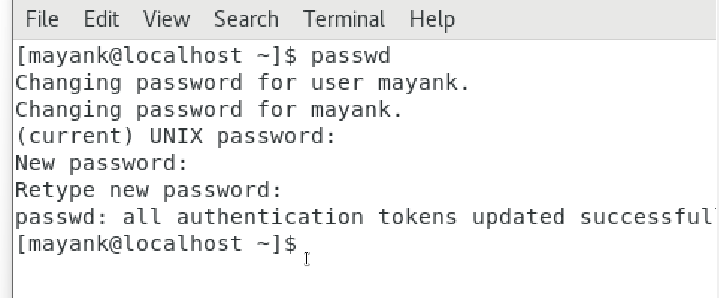[1] Changed the user password to ***IneuR0n#42***

Question2.2 Changed the password top 1234 and abcd

The Below is the Screenshot when the user name Mayank tries to changes a pass and the password is a very common and repetitive in nature, that’s why the error occurs and the pass change fails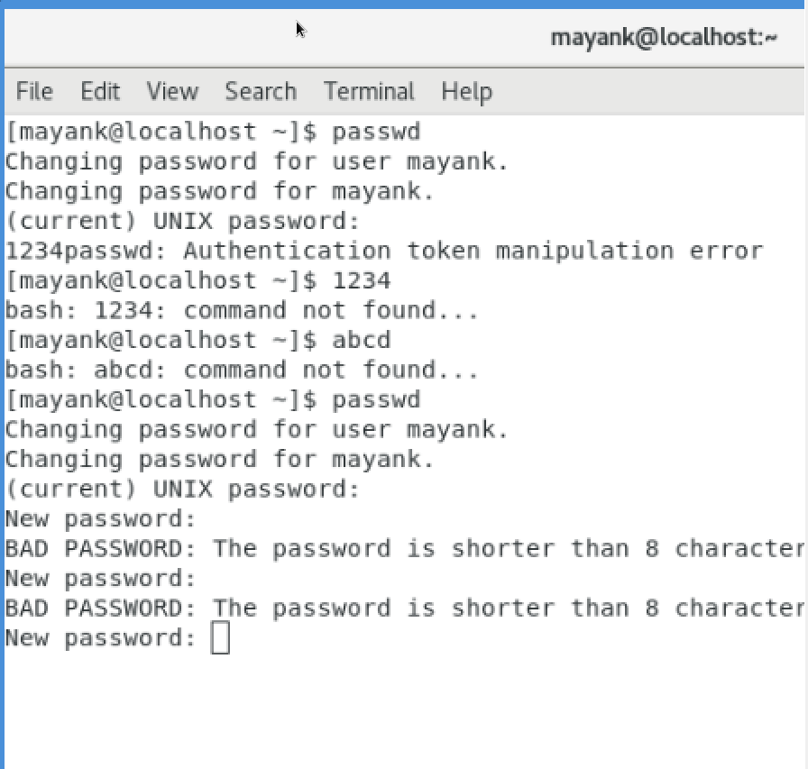

[2] Changed the password top 1234 and abcd

Question 2.3 Changed the password with an empty value

The below is the Screenshot hen user Mayank tries to change the pass with an empty string

But fails again because in this way the password can not set as an empty string.

We can use -d for deleting the pass but still then it will have to go through with sudo command.

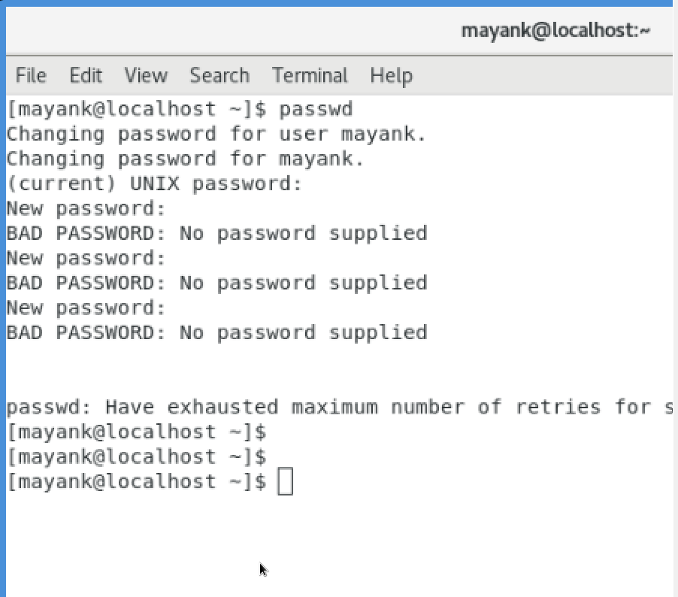[3] Changed the password with an empty value

Question 3 Working with Directories :

The directory commands cd is use to travel in the file system. The cd .. takes you to one step above in the file system.

The use just cd command takes you to /home/mayank dir is new to me.

The ~ shows that you are in /home/user dir where as / shows you are in root

Simply we can’t execute any command in /root folder as a diff user to I had to login as root and then press ls

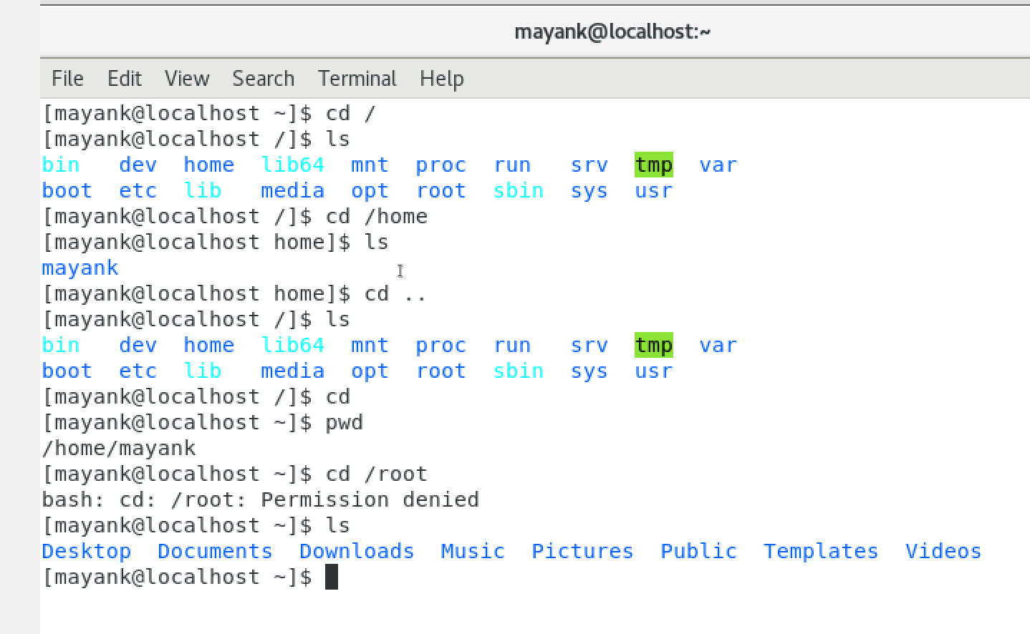

Working with Directories

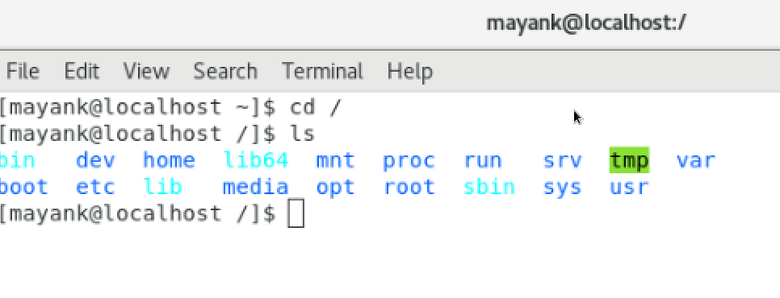

Question 4 : Working with File Listing:

Again the root folder can not be seen by any other user the linux filesystem has /var folder

I will have to check in Linux documentation for more details on what these folder means

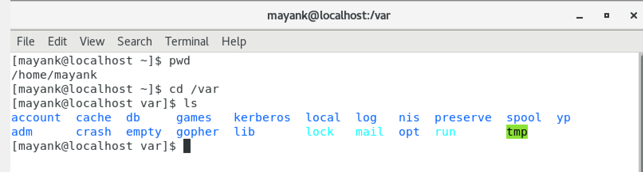

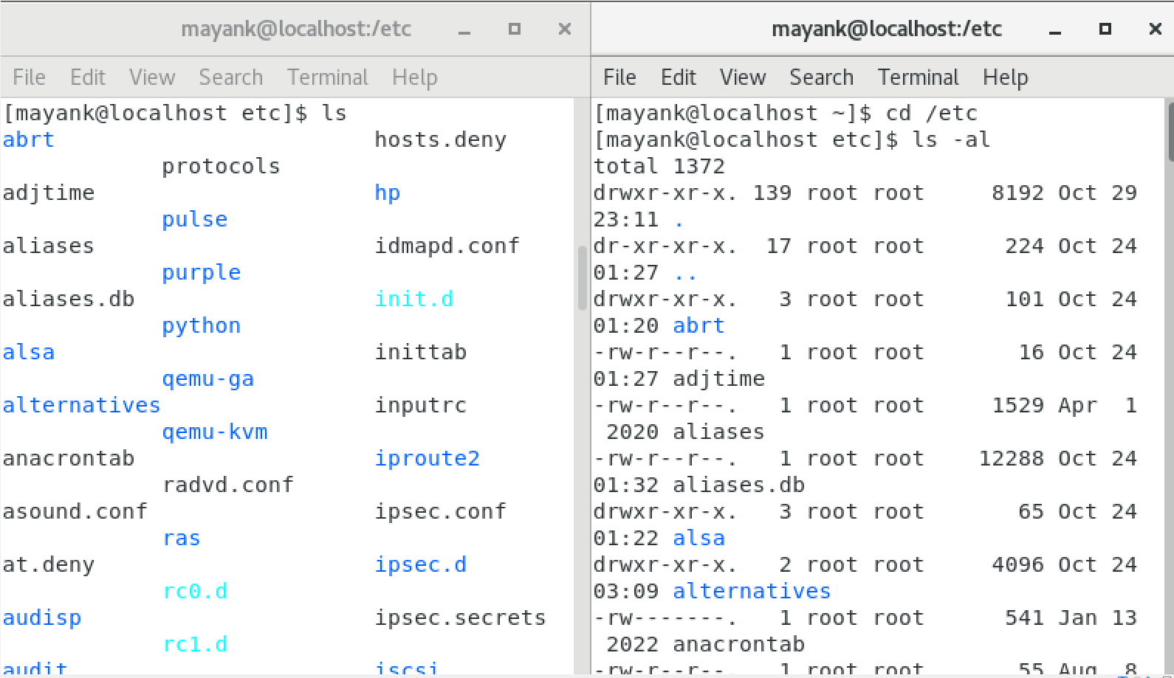

The diff between a simple ls and ls -al or any other ls command with options is it gives an elaborated

View of the file system with other details also

Question5 Know where you are and where you working





1.
2.
3.